SecureBank Financial
SecureMobile Banking Platform: Quantitative Risk Assessment and Executive Briefing

Phase 1: Risk Exposure Calculation

Task 1: Annualized Loss Expectancy (ALE)
Formulas: SLE = Asset Value x Exposure Factor (units at risk x loss per unit). ALE = SLE x ARO.
Finding 1, API Authentication Bypass: SLE = $5,000,000 (maximum single incident loss). ARO = 0.15. ALE = $5,000,000 x 0.15 = $750,000
Finding 2, Database Injection: SLE = 500,000 records x $250 = $125,000,000. ARO = 0.25. ALE = $125,000,000 x 0.25 = $31,250,000
Finding 3, Session Hijacking: SLE = 5,000 accounts x $1,500 = $7,500,000. ARO = 0.40. ALE = $7,500,000 x 0.40 = $3,000,000
Total ALE = $35,000,000 per year

Task 2: Risk Prioritization Matrix
Vulnerability | SLE | ARO | ALE | Share of ALE | Priority Level
Database Injection | $125,000,000 | 25% | $31,250,000 | 89.3% | 1 - High
Session Hijacking | $7,500,000 | 40% | $3,000,000 | 8.6% | 2 - Medium
API Authentication Bypass | $5,000,000 | 15% | $750,000 | 2.1% | 3 - Low
Total |  |  | $35,000,000 | 100%

Priority rule: High if ALE is $10M or more, Medium if $1M to $10M, Low if under $1M.

Task 3: Risk Visualization
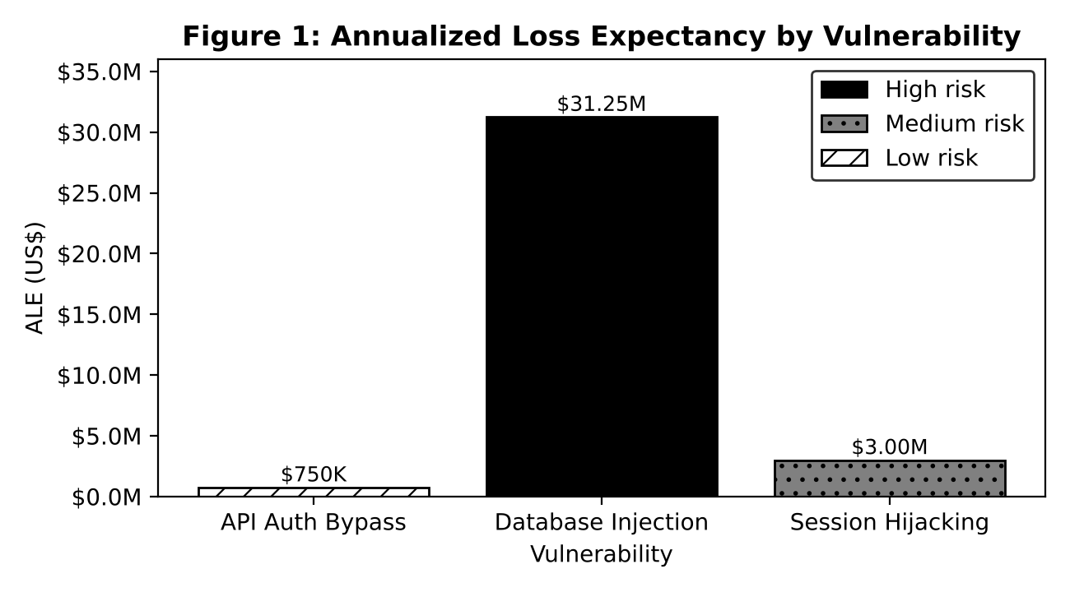
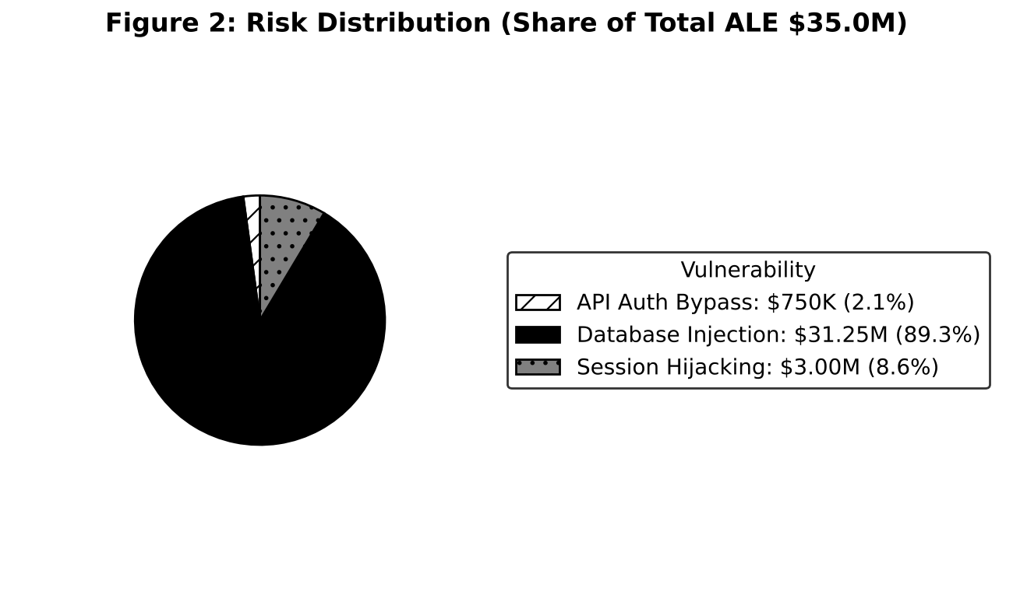
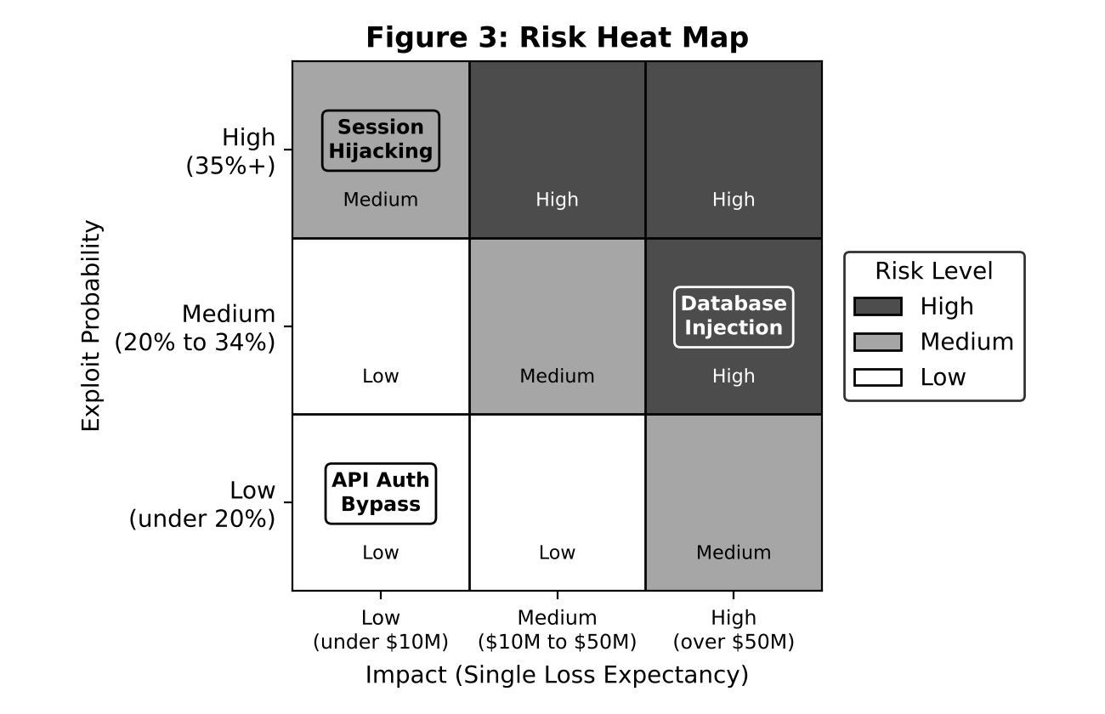
Heat map scoring: Probability level (1 to 3) x Impact level (1 to 3). Score 6 to 9 is High, 3 to 5 is Medium, 1 to 2 is Low. Database Injection is the only High risk.

Phase 2: Control Evaluation

Task 4: Cost-Benefit Analysis
Formulas: Risk Reduction = ALE x Effectiveness. Year 1 Cost = Initial + Maintenance. ROI = (Risk Reduction - Year 1 Cost) / Year 1 Cost. Payback = Initial Cost / (Risk Reduction - Maintenance).
Control | Risk Treated | Initial Investment | Annual Maintenance | Risk Reduction ($/yr) | ROI (Year 1) | Payback Period
API Security Gateway | API Auth Bypass | $350,000 | $50,000 | $675,000 | 68.8% | 6.7 months
Web Application Firewall | Database Injection | $150,000 | $25,000 | $23,437,500 | 13,292.9% | 2.3 days
MFA Enhancement | Session Hijacking | $200,000 | $30,000 | $2,850,000 | 1,139.1% | 26 days
All three | All | $700,000 | $105,000 | $26,962,500 | 3,249.4% | 9.5 days

Workings:
- API Gateway: $750,000 x 90% = $675,000. ROI = ($675,000 - $400,000) / $400,000 = 68.8%. Payback = $350,000 / $625,000 = 0.56 years.
- WAF: $31,250,000 x 75% = $23,437,500. ROI = ($23,437,500 - $175,000) / $175,000 = 13,292.9%. Payback = $150,000 / $23,412,500 = 0.0064 years.
- MFA: $3,000,000 x 95% = $2,850,000. ROI = ($2,850,000 - $230,000) / $230,000 = 1,139.1%. Payback = $200,000 / $2,820,000 = 0.071 years.

Task 5: Control Selection Analysis
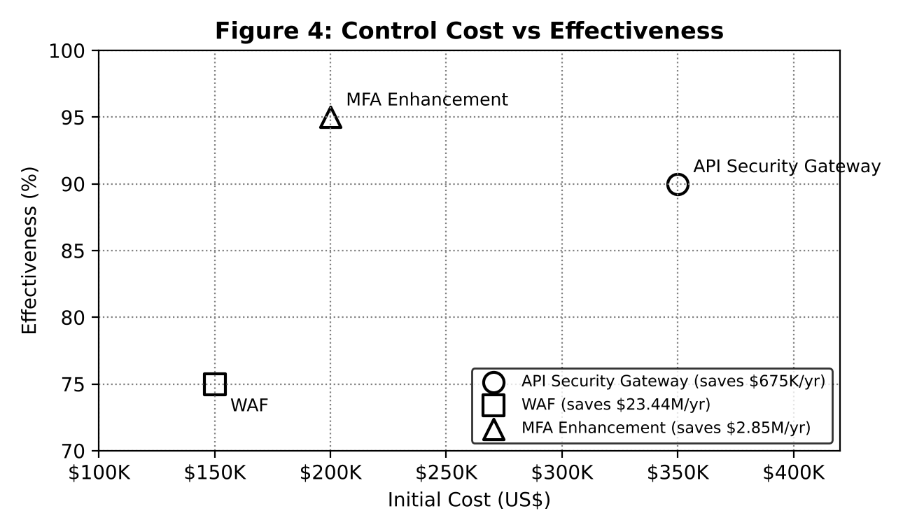
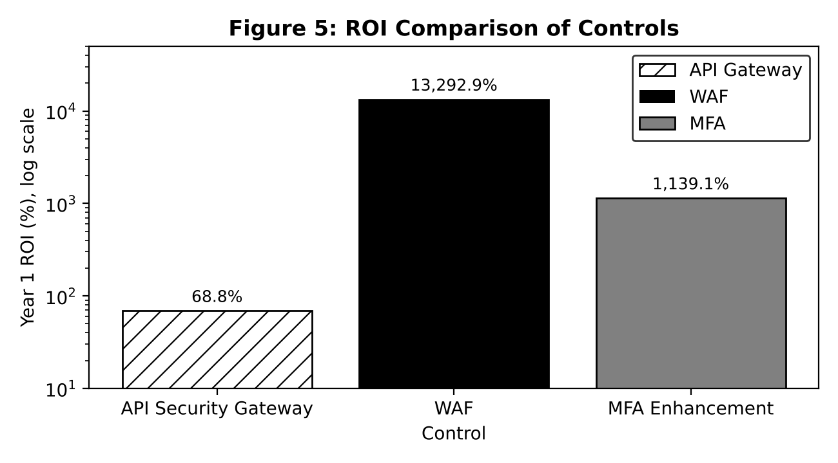
ROI is shown on a log scale because the WAF return is far larger than the other two.
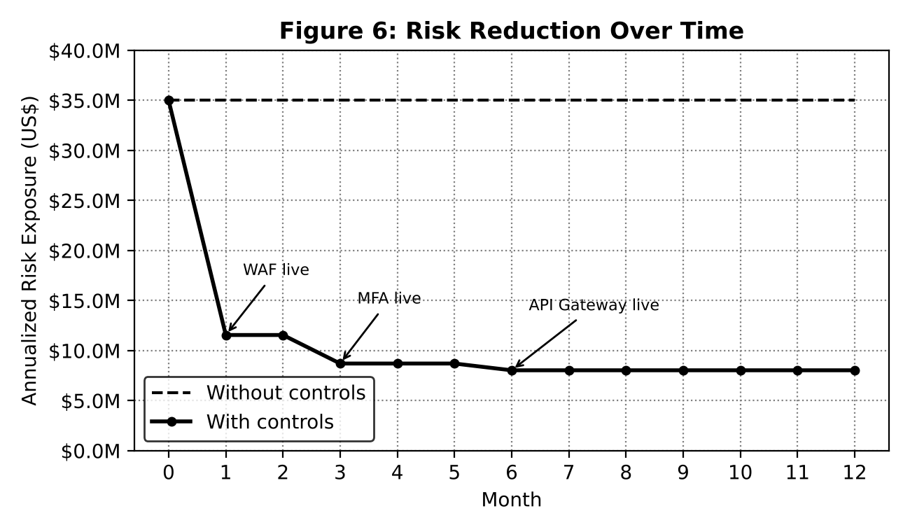
Exposure falls from $35.0M to $11.6M once the WAF is live (month 1), to $8.7M after MFA (month 3) and to $8.0M after the API Gateway (month 6).

Phase 3: Executive Reporting

Task 6: Executive Dashboard
Bottom line: Current exposure is $35.0M a year. Investing $700,000 (plus $105,000 a year) cuts it to $8.0M, a 77% reduction with a 3,249% first-year ROI.
Top 3 Risks | ALE | Priority | Control | Cost (Initial + Year 1 Maintenance) | Risk Reduction | ROI
Database Injection | $31.25M | High | WAF | $150K + $25K | $23.44M | 13,293%
Session Hijacking | $3.00M | Medium | MFA Enhancement | $200K + $30K | $2.85M | 1,139%
API Auth Bypass | $0.75M | Low | API Security Gateway | $350K + $50K | $0.68M | 69%
Total | $35.00M |  | All three | $700K + $105K | $26.96M (77%) | 3,249%

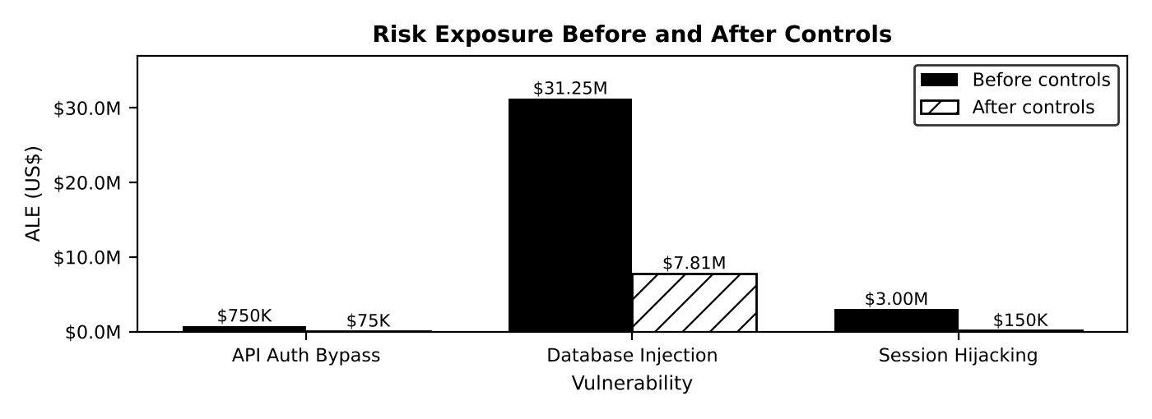
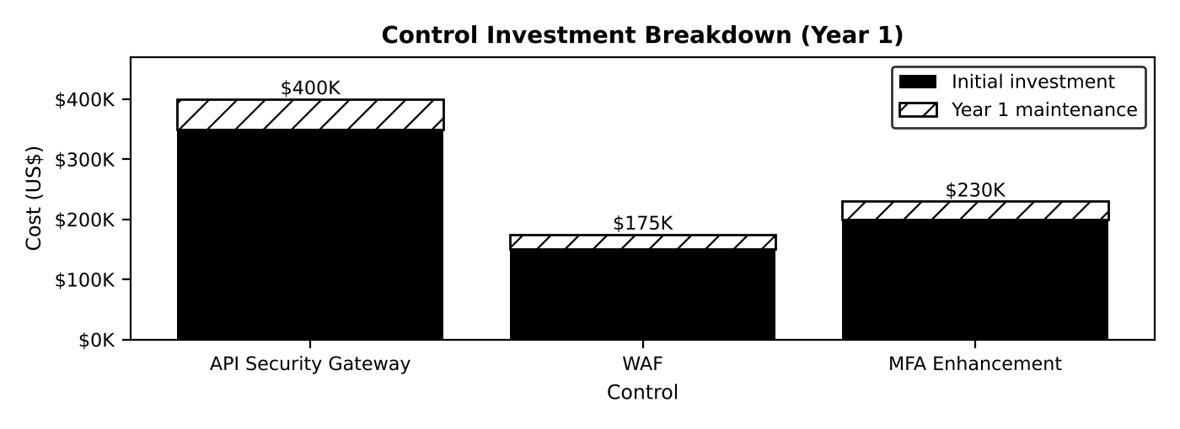
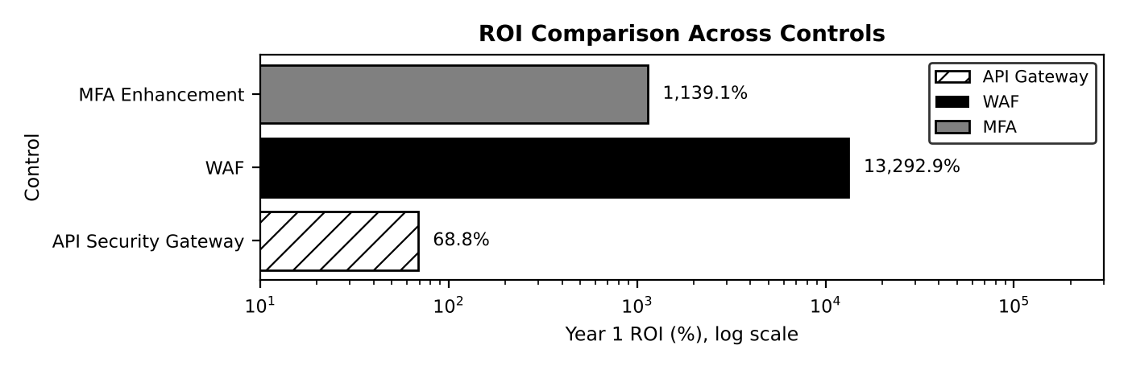

Task 7: Risk Treatment Timeline
Phase | Actions | Days
Immediate (first 30 days) | Patch SQL injection; deploy WAF in blocking mode; shorten session timeouts and rotate tokens; add API transaction limits and fraud alerts | 0 to 30
Short-term (90 days) | Roll out MFA enhancement to all users; procure and design the API Security Gateway | 31 to 90
Long-term (1 year) | Deploy and tune API Security Gateway; continuous monitoring and SIEM tuning; follow-up penetration test; annual risk reassessment | 91 to 365

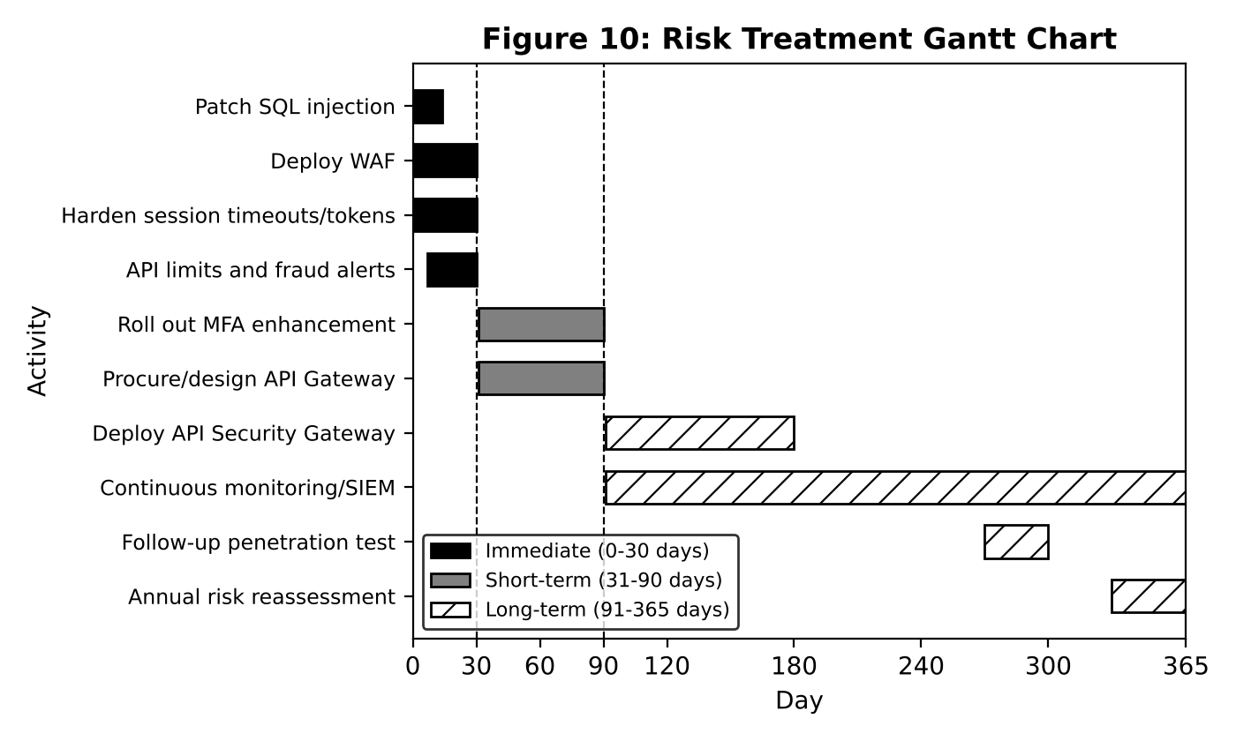

Financial Justification
- Every control returns more than it costs in year one, so all three are justified.
- The WAF alone removes 67% of total exposure for $175,000 in year one and pays back in about 2 days.
- Total 3-year cost is $1,015,000 ($700,000 + 3 x $105,000) against $80.9M of avoided expected loss.

Bonus: Combined Risk-Control Matrix
Risk | Current ALE | Control | Year 1 Cost | Risk Reduction | Residual ALE | Benefit per $1
Database Injection | $31,250,000 | WAF | $175,000 | $23,437,500 | $7,812,500 | $133.93
Session Hijacking | $3,000,000 | MFA | $230,000 | $2,850,000 | $150,000 | $12.39
API Auth Bypass | $750,000 | API Gateway | $400,000 | $675,000 | $75,000 | $1.69
Total | $35,000,000 |  | $805,000 | $26,962,500 | $8,037,500 | $33.49

Optimal selection by budget (fund controls in order of benefit per dollar):
Initial Budget | Controls Funded | Risk Reduction ($/yr) | Residual ALE
$150,000 | WAF | $23,437,500 | $11,562,500
$350,000 | WAF + MFA | $26,287,500 | $8,712,500
$700,000 | WAF + MFA + API Gateway | $26,962,500 | $8,037,500

Recommendation: fund the WAF first, MFA second, and the API Gateway when budget allows. The residual $7.8M database risk should be reduced further through secure coding, encryption of stored data and database activity monitoring.

